here do you think these well-known companies position themselves in the market?

* Mercedes-Benz
* British Airways
* Apple
* Hyundai
* Easyjet
* John Lewis

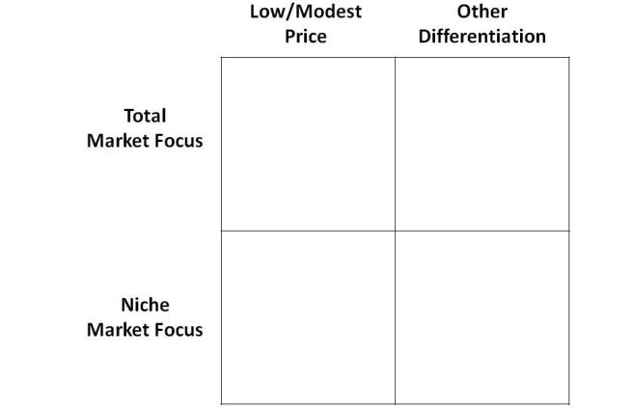

Now, indicate where your business currently is and where you want it to be.

Deciding which box you fit into (or wish to fit into) will help you write your business plan, focus your marketing and define your Unique Selling Proposition (USP).

Here’s another way to apply Porter’s principles to your business:

First, make a list of the principal products and services that you offer.

Now plot these on Grid A below:

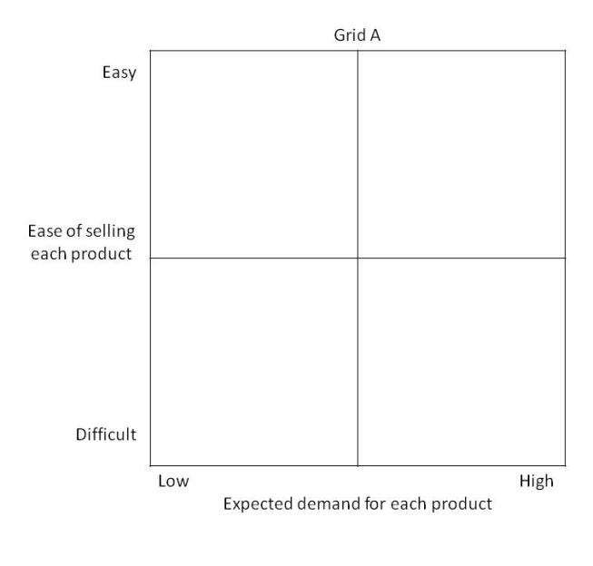

Next, make a list of the principal industries, professions and types of customers that you serve. Plot each of these on Grid B below: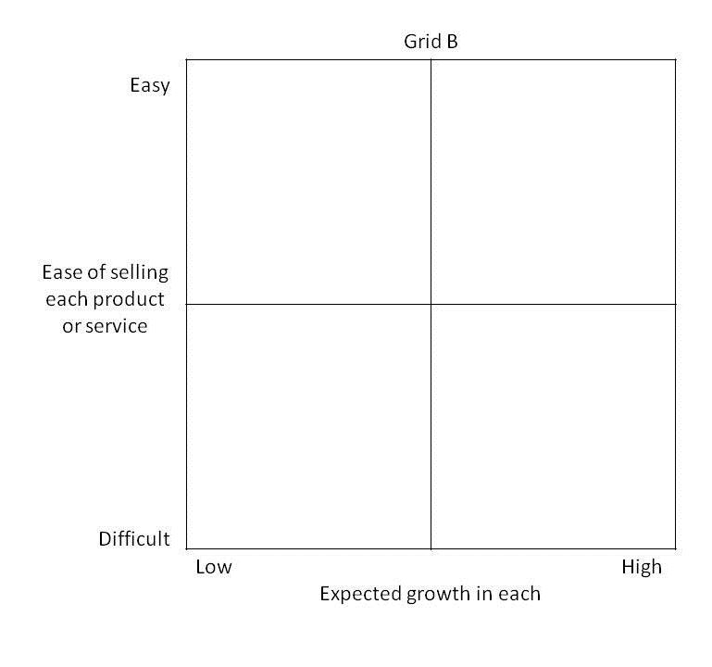This exercise will tell you where to focus your marketing efforts, namely in the upper right-hand quarter of each grid (high growth and relatively easy). By focusing your energy on offering the right things to the right groups, your marketing will be more successful.